NEWSLETTER

20th September 2019

**Team St Edmund’s**

We have re named all of our classes this year with team names. Each class is a colour and collectively we make a complete colour wheel.

Nursery Mrs Hartley– Team Red

Reception Mrs Bradbury –Team Orange

Reception Miss Howard – Team Yellow

Year 1/2 Miss Ward – Team Lime

Year 1/2 Mrs Eccleshare – Team Emerald

Year 1/2 Miss Berry – Team Jade

Year 3/4 Mrs Dumbleton – Team Teal

Year 3/4 Mrs Brookes – Team Sapphire

Year 3/4 Mrs Gredecki & Mr Bale – Team Navy

Year 5/6 Mr Holcroft – Team Amethyst

Year 5/6 Miss Rogers – Team Violet

Year 5/6 Mr Warburton – Team Magenta

**As a TEAM we can**

**achieve more!**



**Aldi Stickers**

We are collecting the Aldi stickers for schools. If you shop in Aldi and receive some stickers, please send them into school and help us collect 300 stickers to complete our poster. We’ll hopefully receive an exclusive sports kit and a chance to win £20,000 for school.

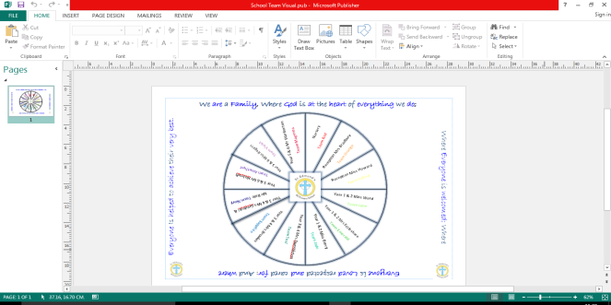

**Mindful Moment**

In school we have introduced ‘Mindfulness Moments’ to encourage children to ‘be’ in the moment. This is part of our focus on mental health and wellbeing for everyone.

Try this simple moment at home.

**Dates, Dates, Dates!!**

We have updated the school calendar on our website with dates for the academic year. If you like to plan ahead, take a look and you’ll find lots on here like our Christmas productions,

sports days and much more.

Please let tell us on the door or give the office a quick ring if somebody different is going to collect your child/children. **Help us safeguard all children by keeping us informed.**

**Nits!**

Our unwelcome friends are back! We have had lots of reports of nits already. Please, please, please regularly check your child’s hair. If we all do this and apply regular treatments, we will combat nits in school. We can only do this together.

Helpful website with treatment and prevention information.

[www.nitwitsforkids.com](http://www.nitwitsforkids.com)

**Next Week!**

We have the following briefings in the hall:

Wednesday 25th at 9.00am – Reception Reading Briefing (Reception parent/carers)

Wednesday 25th at 2.30pm –Maths No Problem Briefing (all welcome)